|  |
| --- |
|  |
| Capstone Project Document |

**VIETNAMESE MEDICINAL PLANTS NETWORK**

Report #2 – Screen Design

|  |  |  |
| --- | --- | --- |
| **Vietnamese Medicinal Plants Network** | | |
| **Group Members** | Nguyễn Minh Tiến | SE02545 |
| Trần Bình Khánh | SE02764 |
| Nguyễn Hải Đăng | SE02992 |
| Hoàng Thị Quỳnh | SE02639 |
| **Supervisor** | Mr. Nguyễn Văn Sang | |
| **Project code** | VMN | |

**- Hanoi, 01/2016 -**

# SIGNATURE PAGE

AUTHOR: Nguyễn Hải Đăng 30/01/2016

Team member

Trần Bình Khánh 31/01/2016

Team member

REVIEWERS: Hoàng Thị Quỳnh 02/02/2016

Team member

APPROVAL: Nguyễn Văn Sang --/--/--16

Supervisor

Record of change

*A - Added M - Modified D – Deleted

|  |  |  |  |  |  |
| --- | --- | --- | --- | --- | --- |
| Effective Date | Changed Item | A,M,D | Change Description | Reason for Change | Rev. Number |
| 30/Dec/2016 | Create Screen Design | A | First version | Create Screen Design | 1.0 |
|  |  |  |  |  |  |
|  |  |  |  |  |  |
|  |  |  |  |  |  |
|  |  |  |  |  |  |
|  |  |  |  |  |  |
|  |  |  |  |  |  |

Table of Contents

SIGNATURE PAGE 1

Introduction 3

1.1 Purpose 3

1.2 Definitions, Acronyms and Abbreviations 3

1.3 Overview 3

2 Screen flow 4

2.1 Register 5

2.2 Login 7

2.3 Search 8

2.3.1 Basic Search 8

2.3.2 Advance Search Medicinal Plants Article 9

2.3.3 Advance Search Remedy Article 10

2.4 Medicinal plants 11

2.5 Remedy 12

2.6 Herbal medicine store 13

2.7 Contribute new article 14

2.7.1 Contribute new medicinal plants article 14

2.7.2 Contribute new remedy article 15

2.8 Edit article 16

2.8.1 Edit medicinal plants article 16

2.8.2 Edit remedy article 17

2.9 Profile 18

2.9.1 User profile 18

2.9.2 Update profile 19

2.10 Admin 21

2.10.1 Managing user 22

2.10.2 Managing user information detail 23

2.10.3 New registered herbal medicine store list 24

2.10.4 New registered herbal medicine store detail 25

2.11 Mod 26

# Introduction

## Purpose

To ensure consistency and simplicity in detailed design across all displays within a product interface, as well as across other products used by the same users. Definitions, acronyms, abbreviations, references and overview of VMN website.

## Definitions, Acronyms and Abbreviations

|  |  |  |
| --- | --- | --- |
| Abbreviations | Description | Comment |
| VMN | Vietnamese Medicinal plants Network |  |
| Q&A | Question and Answer |  |

1. Definitions, Acronyms and Abbreviations

## Overview

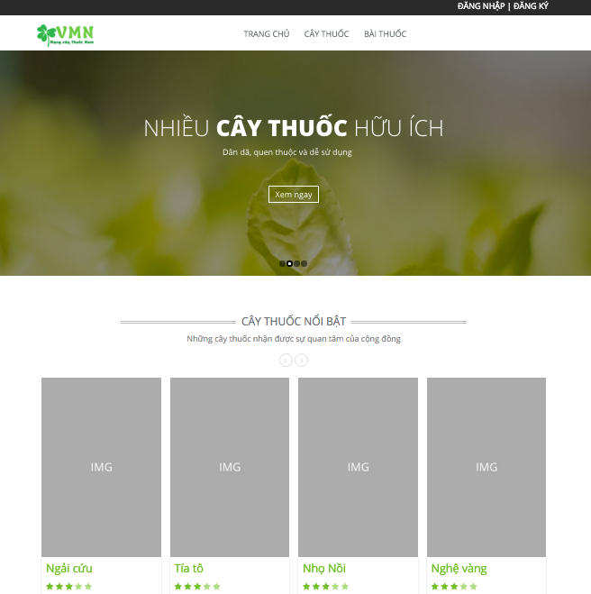

# Screen flow

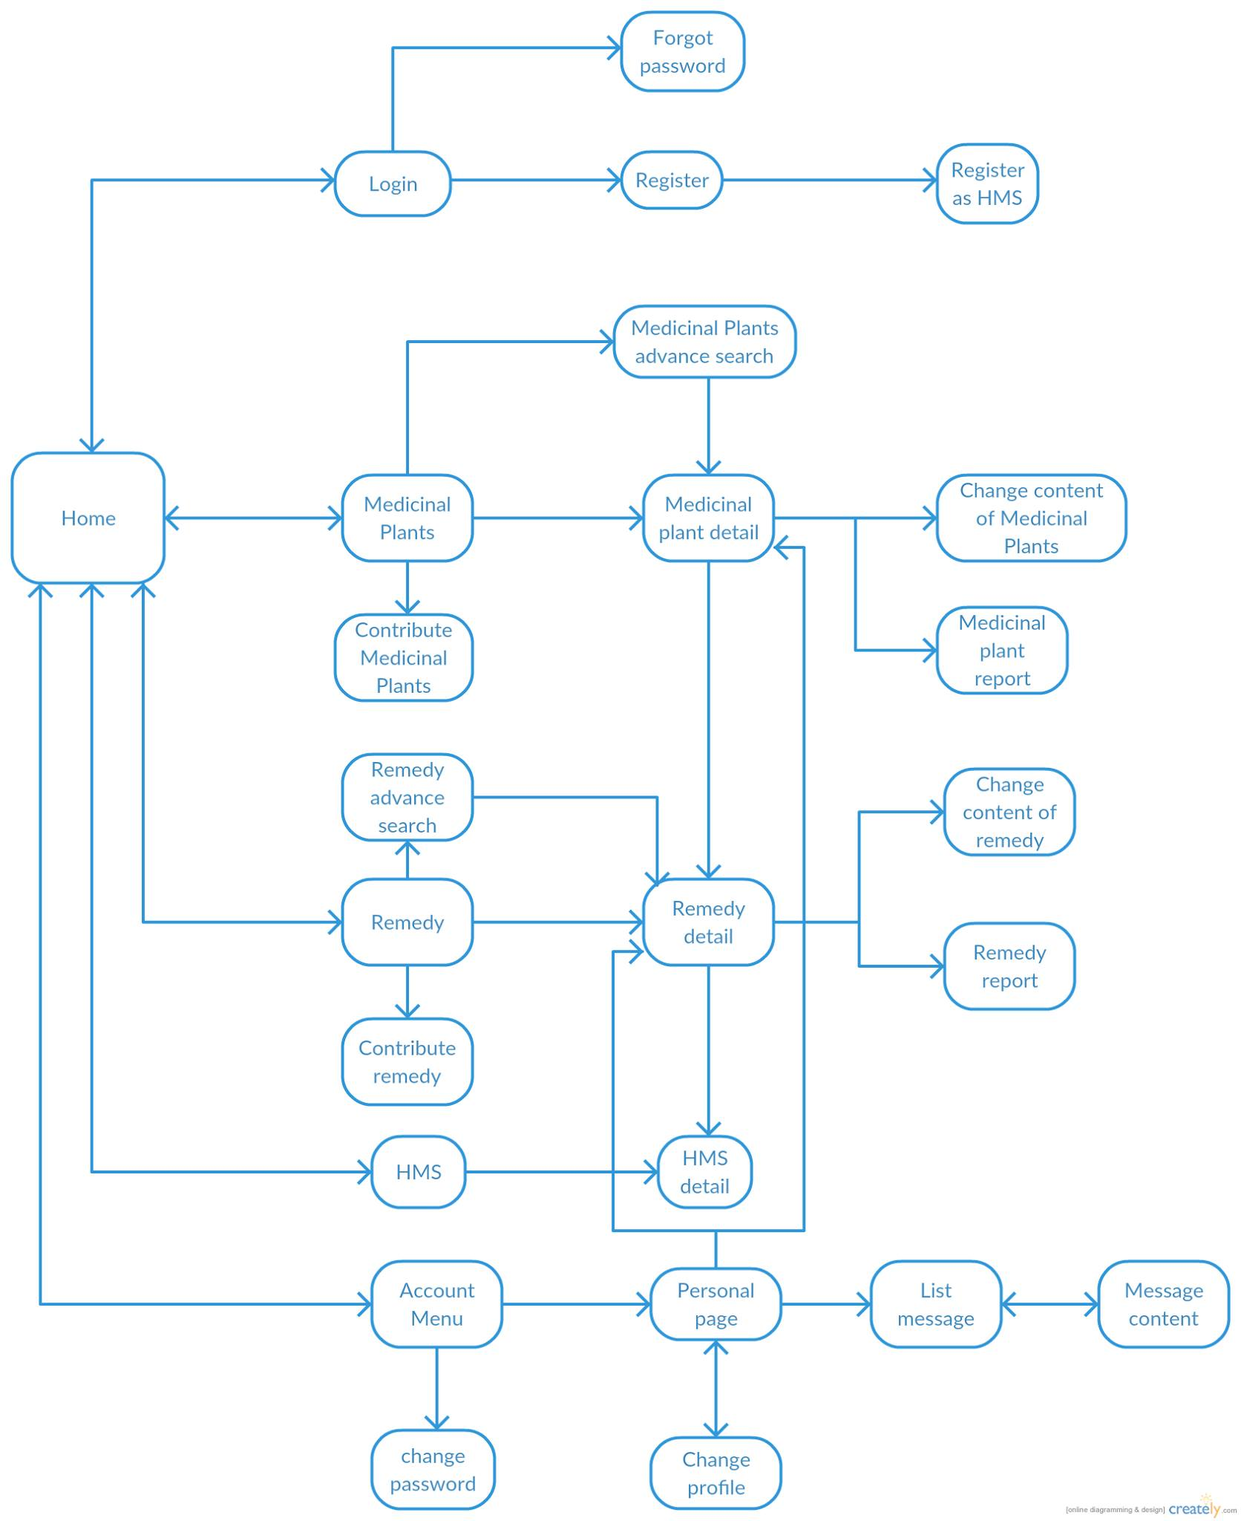

Figure ‑:Client screen flow

## Register

### Normal Account

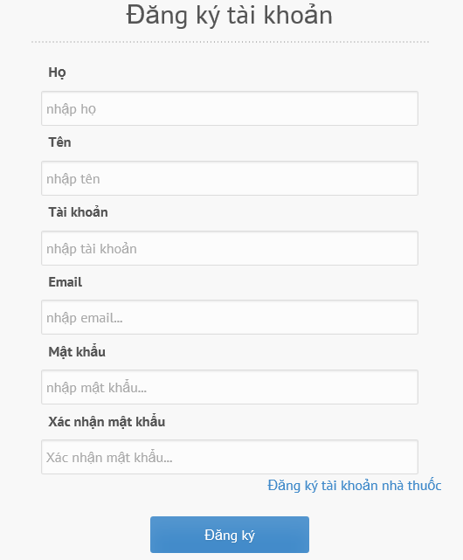

Figure ‑: Register normal account screen

|  |  |  |  |  |  |  |  |
| --- | --- | --- | --- | --- | --- | --- | --- |
| No | Field name | Field name in Vietnamese | Type | Require | Mandatory | Max-Length | Description |
|  | Register Account | Đăng ký tài khoản | Label |  | Y |  | Display register form |
|  | Last name | Họ | Textbox | Type | Y | 8-20 |  |
|  | First name | Tên | Textbox | Type | Y | 8-20 | Name of user |
|  | Account | Tên tài khoản | Textbox | Type | Y | 8-20 | Account of user |
|  | Email | Hòm thư điện tử | Email |  | Y |  | Email of user |
|  | Password | Mật khẩu | Password |  | Y | 8-20 | Password of user’s account |
|  | Confirm Password | Nhập lại mật khẩu | Password |  | Y | 8-20 | Confirm password of user |
|  | Register as Herbal medicine store | Đăng ký tài khoản nhà thuốc | Hyperlink | Click | Y |  | User register as a new Herbal medicine store account |
|  | Sign up | Đăng ký | Button | Click | Y |  | Click to register a new account |

Table ‑: Register normal account screen

### Herbal medicine store account

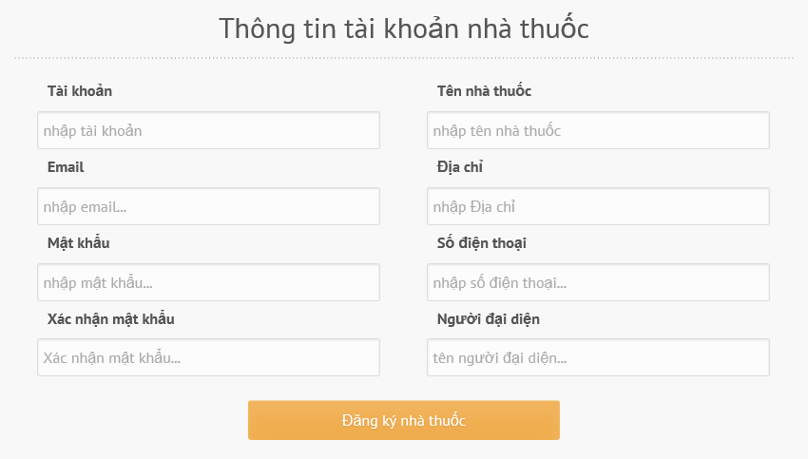

Figure ‑: Register herbal medicine store account screen

|  |  |  |  |  |  |  |  |
| --- | --- | --- | --- | --- | --- | --- | --- |
| No | Field name | Field name in Vietnamese | Type | Require | Mandatory | Max-Length | Description |
|  | Herbal medicine store account information | Thông tin tài khoản nhà thuốc | Label |  | Y |  | Display register form |
|  | Name | Tên | Textbox | Type | Y | 8-20 | Name of herbal medicine store |
|  | Account | Tài khoản | Textbox | Type | Y | 8-20 | Account of herbal medicine store |
|  | Email | Hòm thư điện tử | Email |  | Y |  | Email of herbal medicine store |
|  | Password | Mật khẩu | Password |  | Y | 8-20 | Password of herbal medicine store |
|  | Confirm Password | Nhập lại mật khẩu | Password |  | Y | 8-20 | Confirm password of herbal medicine store |
|  | Address | Địa chỉ | Textbox | Type | Y | 8-50 | Herbal medicine store’s address |
|  | Phone | Điện thoại | Textbox | Type | Y | 8-20 | Phone of herbal medicine store |
|  | Representative | Người đại diện | Textbox | Type | Y | 8-20 | Representative of herbal medicine store |
|  | Sign up | Đăng ký | Button | Click | Y |  | Click to register a new account |

Table ‑: Register herbal medicine store account screen

## Login

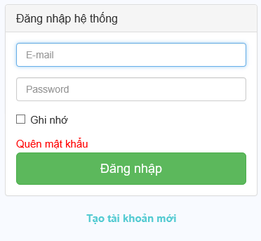

Figure ‑:Login **screen**

|  |  |  |  |  |  |  |  |
| --- | --- | --- | --- | --- | --- | --- | --- |
| No | Field name | Field name in Vietnamese | Type | Require | Mandatory | Max-Length | Description |
|  | Login | Đăng nhập | Label | Type | Y |  | Display text |
|  | Email | Hòm thư điện tử | Email |  | Y |  | Email of registered user |
|  | Password | Mật khẩu | Password |  | Y |  | Password of registered user |
|  | Remember Me | Lưu đăng nhập | Check box | Click | Y |  | Click to save login information |
|  | Forgot Password | Quên mật khẩu | Hyper link | Click | Y |  | Click to resend password to user |
|  | Login | Đăng nhập | Button | Click | Y |  | Click to login |
|  | Register now | Đăng ký ngay | Hyper link | Click | Y |  | Click to register when user have not an account |

Table ‑:Loginscreen

### Forgot password

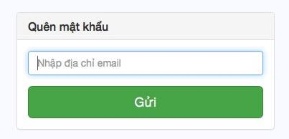

Figure ‑: Forgot password screen

|  |  |  |  |  |  |  |  |
| --- | --- | --- | --- | --- | --- | --- | --- |
| No | Field name | Field name in Vietnamese | Type | Require | Mandatory | Max-Length | Description |
| 1. | Reset your password | Thiết lập lại mật khẩu | Label |  | Y |  | Display text |
| 2. | Email | Hòm thư điện tử | Email |  | Y | 20 | Email address of user |
| 3. | Send password reset email | Gửi mật khẩu mới tới email | Button | Click | Y |  | Click to send new password to Email |

Table ‑: Forgot password screen

## Search

### Basic Search



Figure ‑: Basic search screen

|  |  |  |  |  |  |  |  |
| --- | --- | --- | --- | --- | --- | --- | --- |
| No | Field name | Field name in Vietnamese | Type | Require | Mandatory | Max-Length | Description |
|  | Search box | Ô tìm kiếm | Text | Type | Y | 20 | Search by medicinal plants keyword |
|  | Search icon | Biểu tượng tìm kiếm | Button | Click | Y |  | Click to search medicinal plants |

Table ‑: Basic search screen

### Advance Search Medicinal Plants

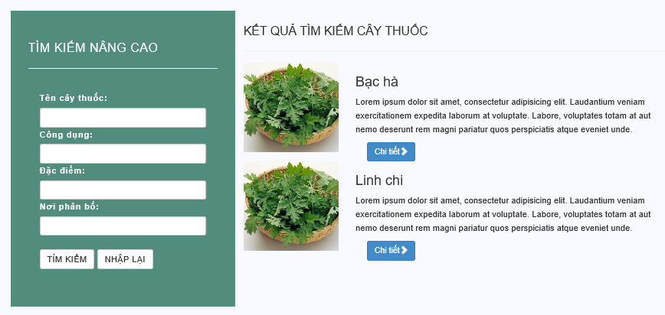

Figure ‑: Advance search medicinal plants screen

|  |  |  |  |  |  |  |  |
| --- | --- | --- | --- | --- | --- | --- | --- |
| No | Field name | Field name in Vietnamese | Type | Require | Mandatory | Max-Length | Description |
|  | Advance search | Tìm kiếm nâng cao | Label |  | Y |  | Display text |
|  | Medicinal plants name | Tên cây thuốc | Text | Type | Y | 20 | Member, Mod type medicinal plants name |
|  | Utility | Công dụng | Text | Type | Y | 20 | Member, Mod type utility |
|  | Characteristic | Đặc điểm | Text | Type | Y | 20 | Member, Mod type characteristic |
|  | Allocation place | Nơi phân bố | Text | Type | Y | 20 | Member, Mod type allocation place of medicinal plants |
|  | Search | Tìm kiếm | Button | Click | Y |  | Click to search medicinal plants |
|  | Reset | Nhập lại | Button | Click | Y |  | Click to reset all text area |
|  | Result | Kết quả tìm kiếm cây thuốc | Label |  | Y |  | Display text |
|  | Medicinal plants searching result | Danh sách cây thuốc | List |  | Y |  | Show medicinal plants as list by suitable keywords |
|  | Detail | Chi tiết | Button | Click | Y |  | Click to show medicinal plants detail |

Table ‑: Advance search medicinal plants screen

### Advance Search Remedy

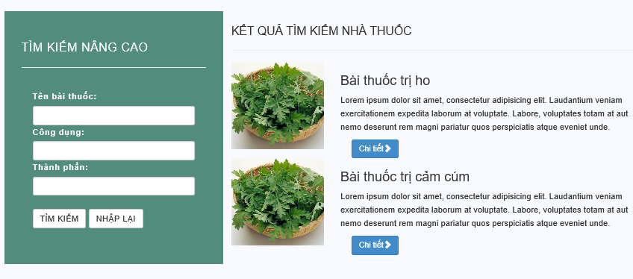

Figure ‑: Advance search remedy screen

|  |  |  |  |  |  |  |  |
| --- | --- | --- | --- | --- | --- | --- | --- |
| No | Field name | Field name in Vietnamese | Type | Require | Mandatory | Max-Length | Description |
|  | Advance search | Tìm kiếm nâng cao | Label |  | Y |  | Display text |
|  | Remedy | Tên bài thuốc | Text | Type | Y | 20 | Member, Mod type remedy name |
|  | Utility | Công dụng | Text | Type | Y | 20 | Member, Mod type utility |
|  | Ingredients | Thành phần | Text | Type | Y | 20 | Member, Mod type element |
|  | Search | Tìm kiếm | Button | Click | Y |  | Click to search remedy |
|  | Reset | Nhập lại | Button | Click | Y |  | Click to reset all text area |
|  | Result | Kết quả tìm kiếm bài thuốc | Label |  | Y |  | Display text |
|  | Remedy searching result | Danh sách bài thuốc | List |  | Y |  | Show remedies as list by suitable keywords |
|  | Detail | Chi tiết | Button | Click | Y |  | Click to show remedy detail |

Table ‑: Advance search remedy screen

## Medicinal plants

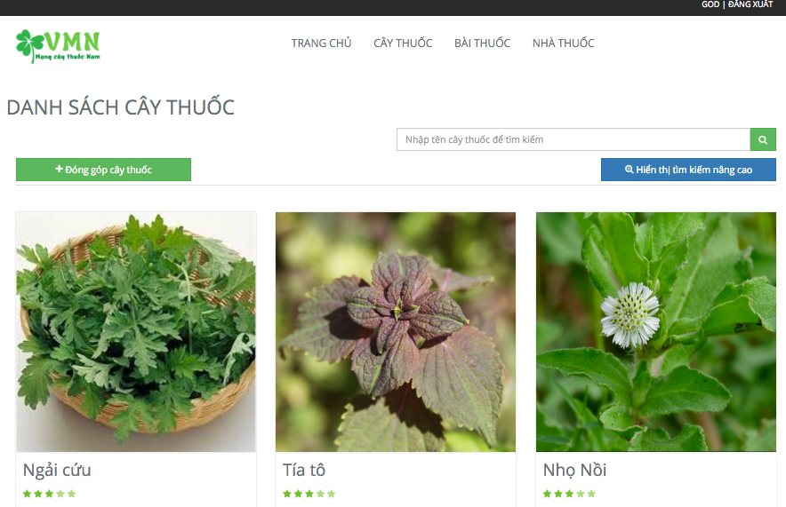

Figure ‑: Medicinal plants screen

|  |  |  |  |  |  |  |  |
| --- | --- | --- | --- | --- | --- | --- | --- |
| No | Field name | Field name in Vietnamese | Type | Require | Mandatory | Max-Length | Description |
| 1. | Banner | Quảng cáo | Picture |  | Y |  |  |
| 2. | Search box | Ô tìm kiếm | Text | Type | Y | 20 | Search by medicinal plants keyword |
| 3. | Search icon | Biểu tượng tìm kiếm | Button | Click | Y |  | Click to search |
| 4. | Contribute medicinal plants | Đóng góp cây thuốc | Button | Click | Y |  | Member, Mod click to contribute new medicinal plants article |
| 5. | Medicinal plants list | Danh sách cây thuốc | List |  | Y |  | Show medicinal plants list |
| 6. | Detail | Chi tiết | Button | Click | Y |  | Click to show medicinal plants article detail |
| 7. | Paging bar | Thanh đánh số trang | Button | Click | Y |  | Click to select page |

Table ‑: Medicinal plants screen

## Remedy

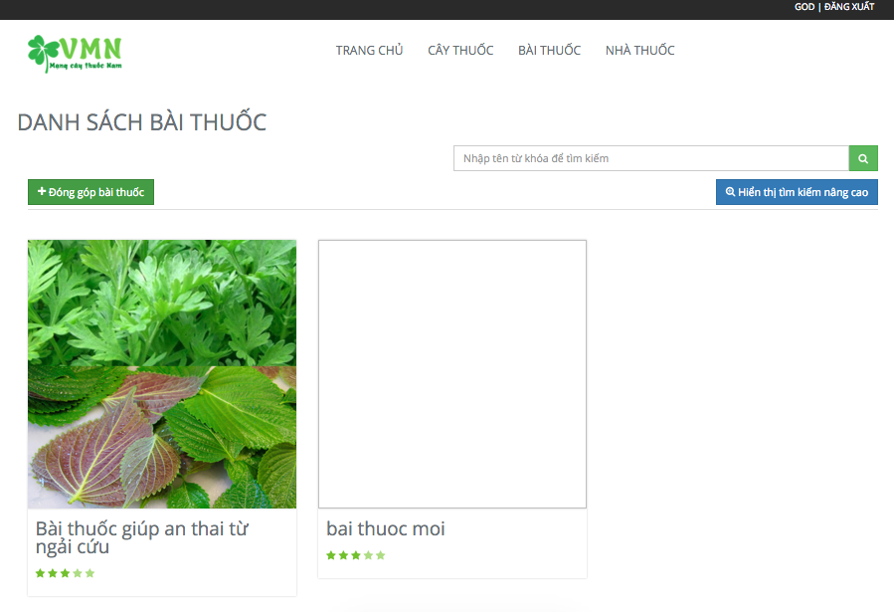

Figure ‑: Remedy screen

|  |  |  |  |  |  |  |  |
| --- | --- | --- | --- | --- | --- | --- | --- |
| No | Field name | Field name in Vietnamese | Type | Require | Mandatory | Max-Length | Description |
| 1. | Banner | Quảng cáo | Picture |  | Y |  |  |
| 2. | Search box | Ô tìm kiếm | Text | Type | Y | 20 | Search by medicinal plants keyword |
| 3. | Search icon | Biểu tượng tìm kiếm | Button | Click | Y |  | Click to search |
| 4. | Contribute remedy | Đóng góp bài thuốc | Button | Click | Y |  | Member, Mod click to contribute new remedy article |
| 5. | Remedy list | Danh sách bài thuốc | List |  | Y |  | Show remedy list |
| 6. | Detail | Chi tiết | Button | Click | Y |  | Click to show a remedy article detail |
|  | Paging bar | Thanh đánh số trang | Button | Click | Y |  | Click to select page |

Table ‑: Remedy screen

## Herbal medicine store

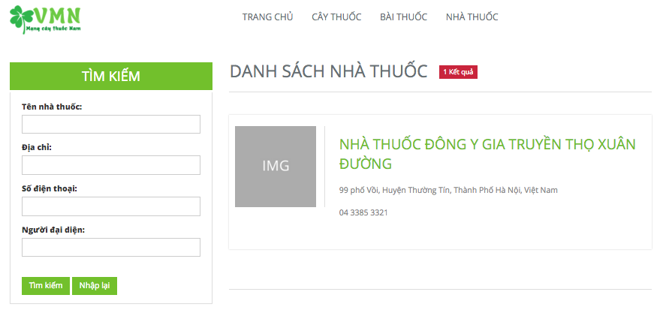

Figure ‑: Herbal medicine store screen

|  |  |  |  |  |  |  |  |
| --- | --- | --- | --- | --- | --- | --- | --- |
| No | Field name | Field name in Vietnamese | Type | Require | Mandatory | Max-Length | Description |
|  | Search herbal medicine store | Tìm kiếm nhà thuốc | Label |  | Y |  | Display text |
|  | Herbal medicine store | Tên nhà thuốc | Text | Type | Y | 20 | Member, Mod type herbal medicine store’s name |
|  | Address | Địa chỉ nhà thuốc | Text | Type | Y | 20 | Member, Mod type address of herbal medicine store |
|  | Search | Tìm kiếm | Button | Click | Y |  | Click to search herbal medicine store |
|  | Reset | Nhập lại | Button | Click | Y |  | Click to reset all text area |
|  | Herbal medicine store searching result | Kết quả tìm kiếm nhà thuốc | Label |  | Y |  | Display herbal medicine store searching result |
|  | Herbal medicine store list | Danh sách nhà thuốc | List |  | Y |  | Show herbal medicine store as list by suitable keywords |
|  | Detail | Chi tiết | Button | Click | Y |  | Click to show Herbal medicine store detail |

Table ‑: Herbal medicine store screen

### Herbal medicine store detail

Figure ‑: Herbal medicine store detail

|  |  |  |  |  |  |  |  |
| --- | --- | --- | --- | --- | --- | --- | --- |
| No | Field name | Field name in Vietnamese | Type | Require | Mandatory | Max-Length | Description |
|  | Contact information | Thông tin liên hệ | Label |  | Y |  | Show herbal medicine store  Detail. |
|  | Name | Tên | Textbox | Type | Y | 20 | Name of user to communicate with herbal medicine store |
|  | Email | Thư điện tử | Email | Type | Y |  | Email of user to communicate with herbal medicine store |
|  | Address | Nội dung | Text area | Type | Y | 200 | To write communicate content |
|  | Phone | Điện thoại | Integer | Type | Y | 15 | To write HMS phone number |

Table ‑: Herbal medicine store detail

## Contribute new article

### Contribute new medicinal plants

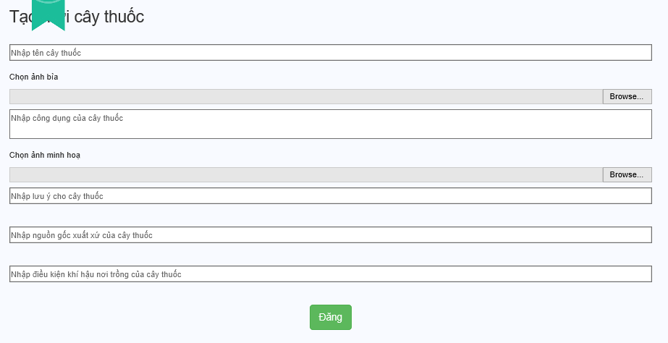

Figure ‑: Contribute new medicinal plants screen

|  |  |  |  |  |  |  |  |
| --- | --- | --- | --- | --- | --- | --- | --- |
| No | Field name | Field name in Vietnamese | Type | Require | Mandatory | Max-Length | Description |
| 1. | Contribute new medicinal plants | Đóng góp cây thuốc mới | Label |  | Y |  | Display text |
| 2. | backgroud | Ảnh đại diện | Button | Click | Y |  | Click to up image of medicinal plants |
| 3. | Name | Tên | Text | Type | Y | 20 | Name of medicinal plants |
| 4. | Other name | Tên khác | Text | Type | Y | 200 | Other name of medicinal plants |
| 5. | Science name | Tên khoa học | Text | Type | Y | 20 | Science name of medicinal plants |
| 6. | Characteristic | Đặc tính | Text | Type | Y | 200 | Characteristic of medicinal plants |
| 7. | Utility | Công dụng | Text | Type | Y | 500 | Utility of medicinal plants |
| 8. | Example picture | Ảnh minh họa | Button | Click | Y |  | Click to up example picture of medicinal plants |
| 9. | Note | Lưu ý | Text | Type | Y | 500 | Note for medicinal plants |
| 10. | Allocation place | Nguồn gốc xuất xứ | Text | Type | Y | 200 | Allocation place of medicine plant |
| 11. | Climatic condition | Điều kiện khí hậu nơi trồng | Text | Type | Y | 200 | Climatic condition of medicinal plants |
| 12. | Post | Đăng | Button | Click | Y |  | Click to post medicinal plants new |

Table ‑: Contribute new medicinal plants screen

### Contribute new remedy

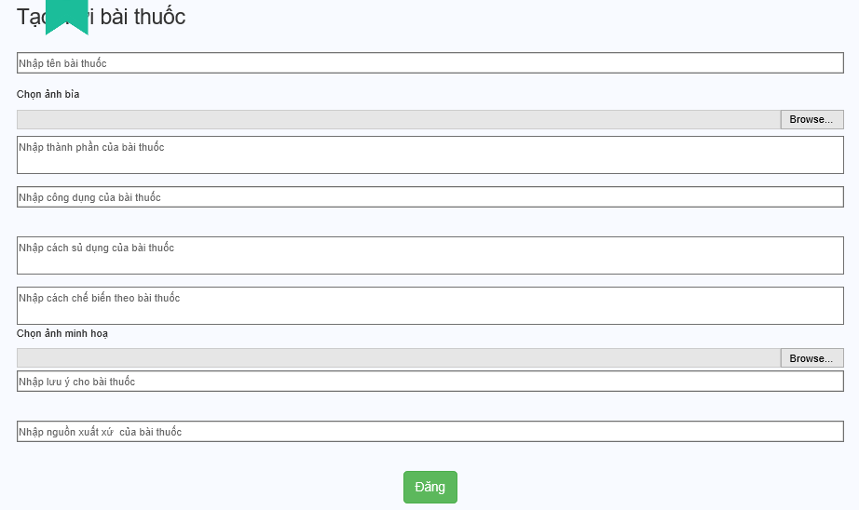

Figure ‑: Contribute new remedy screen

|  |  |  |  |  |  |  |  |
| --- | --- | --- | --- | --- | --- | --- | --- |
| No | Field name | Field name in Vietnamese | Type | Require | Mandatory | Max-Length | Description |
| 1. | Contribute new remedy | Đóng góp bài thuốc mới | Label |  | Y |  | Display text |
| 2. | Background | Ảnh đại diện | Button | Click | Y |  | Click to up image of remedy |
| 3. | Name | Tên | Text | Type | Y | 20 | Name of remedy |
| 4. | Ingredients | Thành phần bài thuốc | Text | Type | Y | 200 | Ingredients of remedy |
| 5. | Utility | Công dụng | Text | Type | Y | 200 | Utility of remedy |
| 6. | Using | Cách sử dụng | Text | Type | Y | 200 | Using of remedy |
| 7. | Making | Cách chế biến | Text | Type | Y | 200 | Making of remedy |
| 8. | Example pictures | Ảnh minh họa | Text | Type | Y |  | Click to up example pictures |
| 9. | Note | Lưu ý | Text | Type | Y | 200 | Note for remedy |
| 10. | The origin | Nguồn gốc xuất xứ | Text | Type | Y | 20 | The origin of remedy |
| 11. | Contribute | Đăng | Button | Click | Y |  | Click to post remedy new |

Table ‑: Contribute new remedy screen

## Edit article

### Edit medicinal plants article

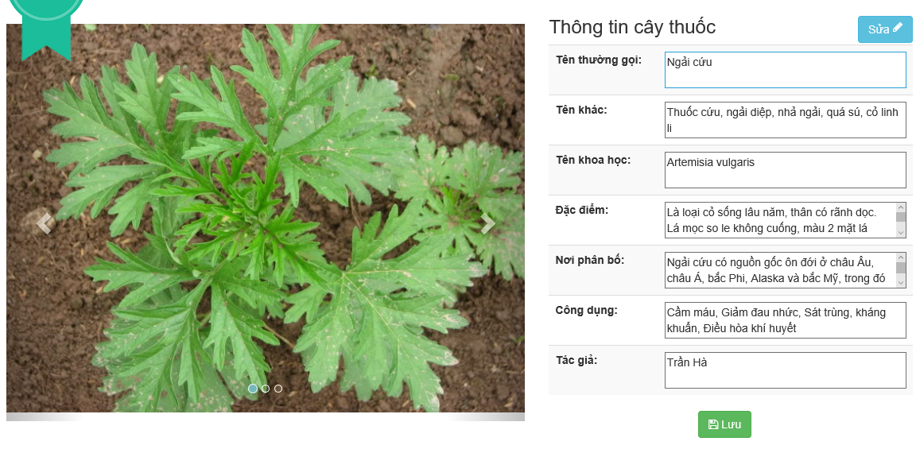

Figure ‑: Edit medicinal plants article screen

|  |  |  |  |  |  |  |  |
| --- | --- | --- | --- | --- | --- | --- | --- |
| No | Field name | Field name in Vietnamese | Type | Require | Mandatory | Max-Length | Description |
| 1. | Picture | Ảnh | Image |  | Y |  | Show medicinal plants picture |
| 2. | Edit | Chỉnh sửa | Button | Click | Y |  | Click edit to edit medicinal article |
| 3. | Medicinal plants picture | Ảnh cây thuốc | Picture | Type | Y |  | Show plant picture |
| 4. | Name | Tên cây thuốc | Text | Type | Y | 8-20 | Show plant name |
| 5. | Other name | Tên khác | Text | Type | Y | 8-200 | Show other name |
| 6. | Science name | Tên khoa học | Text | Type | Y | 8-200 | Show science name |
| 7. | Description | Miêu tả | Text | Type | Y | 500 | Show plant shape |
| 8. | Characteristic | Đặc tính | Text | Type | Y | 500 | Show plant characteristic |
| 9. | Allocation place | Nơi trồng | Text | Type | N | 8-20 | Show allocation place |
| 10. | Utility | Công dụng | Text | Type | Y | 500 | Show plant utility |
| 11. | Save | Lưu | Button | Click | Y |  | User click save to update medicinal article |

Table ‑: Edit medicinal plants article screen

### Edit remedy article

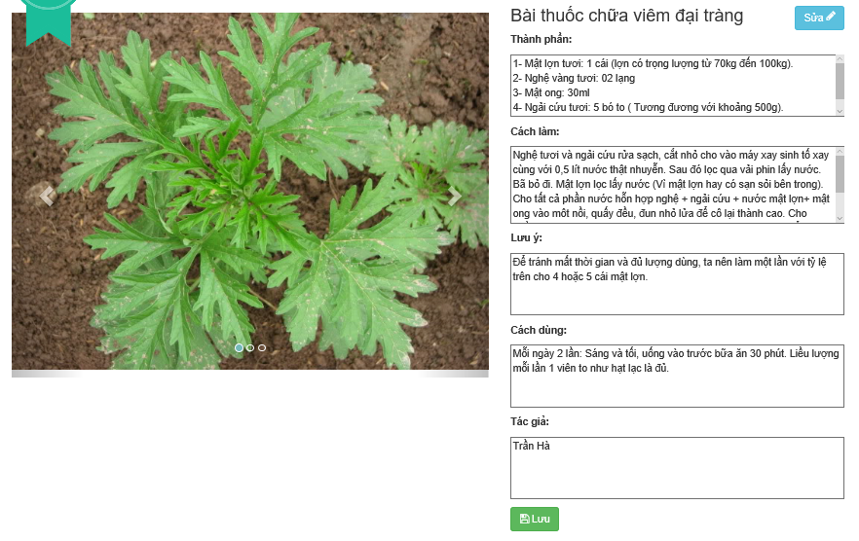

Figure ‑: Edit remedy article screen

|  |  |  |  |  |  |  |  |
| --- | --- | --- | --- | --- | --- | --- | --- |
| No | Field name | Field name in Vietnamese | Type | Require | Mandatory | Max-Length | Description |
| 1. | Picture | Ảnh | Image |  | Y |  | Show remedy picture |
| 2. | Edit | Chỉnh sửa | Button | Click | Y |  | Click edit to edit medicinal article |
| 3. | Ingredients | Thành phần | Text area | Type | Y | 500 | Element of remedy article |
| 4. | Making | Cách làm | Text area | Type | Y | 500 | Show how to make |
| 5. | Note | Chú ý | Text area | Type | Y | 500 | Note when using |
| 6. | Usage | Cách dùng | Text area | Type | Y | 500 | Show how to use |
| 7. | Author | Tác giả | Text area | Type | Y | 8-20 | Author of remedy article |
| 8. | Save | Lưu | Button | Click | Y |  | User click save to update medicinal article |

Table ‑: Edit remedy article screen

## Article detail

### Medicinal plants detail

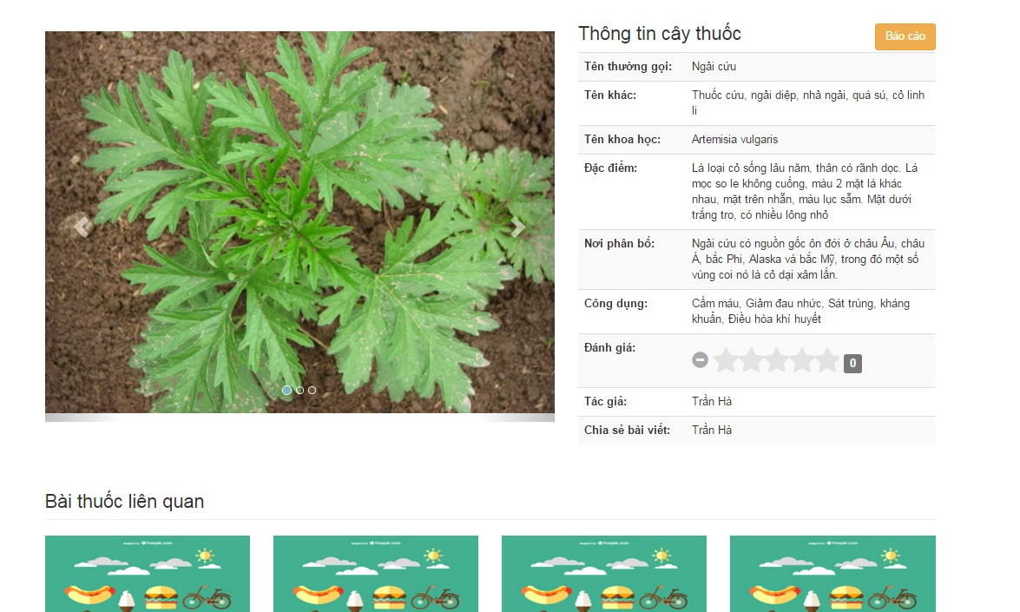

Figure ‑: Medicinal plants detail screen

|  |  |  |  |  |  |  |  |
| --- | --- | --- | --- | --- | --- | --- | --- |
| No | Field name | Field name in Vietnamese | Type | Require | Mandatory | Max-Length | Description |
| 1. | Information of medicinal plants | Thông tin cây thuốc | Label |  | Y |  | Display text |
| 2. | Name | Tên thường gọi | Text | Type | Y |  | Name of medicinal plants |
| 3. | Other name | Tên khác | Text | Type | Y |  | Other name of medicinal plants |
| 4. | Science name | Tên khoa học | Text | Type | Y |  | Science name of medicinal plants |
| 5. | Characteristic | Đặc điểm | Text | Type | Y |  | Characteristic of medicinal plants |
| 6. | Allocation place | Nơi phân bố | Text | Type | Y |  | Allocation place of medicine plant |
| 7. | Utility | Công dụng | Text | Type | Y |  | Utility of medicinal plants |
| 8. | Rate | Đánh giá | Rating | Click | Y |  | Click to assessing the quality of medicinal plants |
|  | Author | Tác giả | Text | Type | Y |  | Author of medicinal plants |
|  | Report | Báo cáo | Button | Click | Y |  | Click to report medicinal plants |
|  | Edit | Chỉnh sửa | Button | Click | Y |  | Click to edit medicinal plants |
|  | Related Remedy | Bài thuốc liên quan | Hyperlink | Click | Y |  | Click to show related remedy |
|  | Comment | Bình luận | Label |  | Y |  | Display text |
|  | Write comment | Viết bình luận | Text Area | Type | Y | 200 | Write comment for medicinal plants |
|  | Post | Đăng | Button | Click | Y |  | Click to post comment |

Table ‑: Medicinal plants detail screen

### Remedy detail

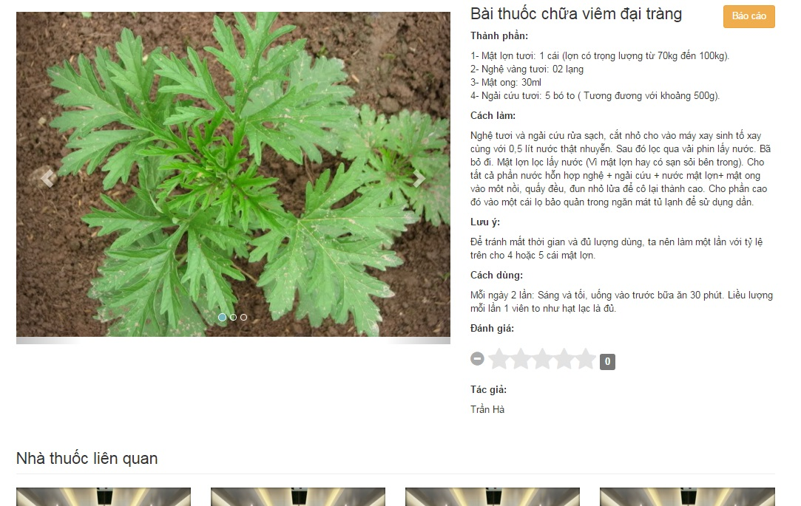

Figure ‑: Remedy detail screen

|  |  |  |  |  |  |  |  |
| --- | --- | --- | --- | --- | --- | --- | --- |
| No | Field name | Field name in Vietnamese | Type | Require | Mandatory | Max-Length | Description |
| 1. | Information of remedy | Thông tin bài thuốc | Label |  | Y |  | Display text |
| 2. | Ingredients | Thành phần | Text | Type | Y | 200 | Ingredients of remedy |
| 3. | Making | Cách chế biến | Text | Type | Y | 200 | Making of remedy |
| 4. | Note | Lưu ý | Text | Type | Y | 200 | Note for remedy |
| 5. | Using | Cách sử dụng | Text | Type | Y | 200 | Using of remedy |
| 6. | Rate | Đánh giá | Rating | Click | Y |  | Click to assessing the quality of remedy |
| 7. | Author | Tác giả | Text | Type | Y |  | Author of remedy |
| 8. | Related herbal medicine store | Nhà thuốc liên quan | Hyperlink | Click | Y |  | Click to show related herbal medicine store |
| 9. | Comment | Bình luận | Label |  | Y |  | Display text |
| 10. | Write comment | Viết bình luận | Text Area | Type | Y | 200 | Write comment for medicinal plants |
| 11. | Post | Đăng | Button | Click | Y |  | Click to post comment |

Table ‑: Remedy detail screen

## Report

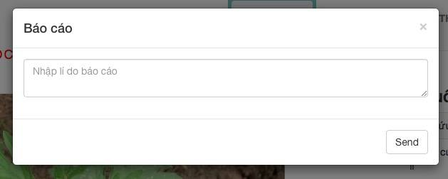

Figure ‑: Report screen

|  |  |  |  |  |  |  |  |
| --- | --- | --- | --- | --- | --- | --- | --- |
| No | Field name | Field name in Vietnamese | Type | Require | Mandatory | Max-Length | Description |
| 1. | Report | Báo cáo | Label |  | Y |  | Display text |
| 2. | Report content | Nội dung báo cáo | Text area | Type | Y | 50 | Content of Report |
| 3. | Send | Gửi | Button | Click | Y |  | Click to send report |

Table ‑: Report screen

## Account menu

### User profile

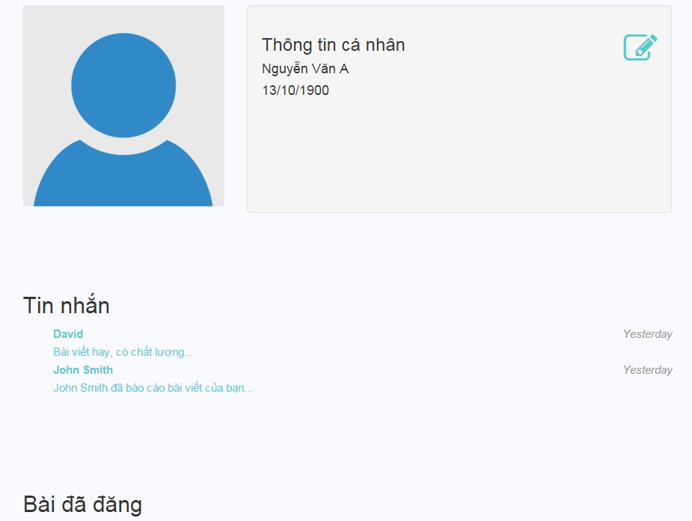

Figure ‑: User profile screen

|  |  |  |  |  |  |  |  |
| --- | --- | --- | --- | --- | --- | --- | --- |
| No | Field name | Field name in Vietnamese | Type | Require | Mandatory | Max-Length | Description |
| 1. | Picture | Ảnh đại diện | Image |  | Y |  | Show remedy picture |
| 2. | User Information | Thông tin cá nhân | Label |  | Y |  | Display text |
| 3. | Edit | Chỉnh sửa | Button | Click | Y |  | Click edit button to edit user information |
| 4. | Full name | Họ tên | Text | Type | Y |  | User full name |
| 5. | Date of birth | Ngày tháng năm sinh | Text | Type | Y |  | User date of birth |
| 6. | Posted Articles | Bài đã đăng | Label |  | Y |  | Display text |
| 7. | Posted articles list | Danh sách các bài đã đăng | Hyperlink | Click | Y |  | Click to show posted articles |
| 8. | List message | Danh sách tin nhắn | Hyperlink | Click | Y |  | Click to show message content |

Table ‑: User profile screen

### Change profile

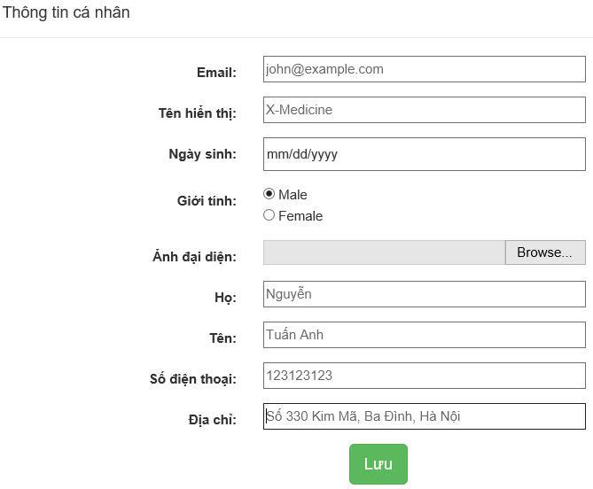

Figure ‑: Change profile screen

|  |  |  |  |  |  |  |  |
| --- | --- | --- | --- | --- | --- | --- | --- |
| No | Field name | Field name in Vietnamese | Type | Require | Mandatory | Max-Length | Description |
| 1. | User Information | Thông tin cá nhân | Label |  | Y |  | Display text |
| 2. | User name | Tên hiển thị | Text | Type | Y | 20 | User name |
| 3. | Date of birth | Ngày sinh | Radio | Click | Y | 10 | Date of birth |
| 4. | Gender | Giới tính | Text | Type | Y |  | Gender of user |
| 5. | Profile picture | Ảnh đại diện | Button | Click | Y |  | Profile picture |
| 6. | Last name | Họ | Text | Type | Y | 20 | Last name of user |
| 7. | First name | Tên | Text | Type | Y | 20 | First name of user |
| 8. | Phone | Số điện thoại | Text | Type | Y | 20 | Phone number of user |
| 9. | Address | Địa chỉ | Text | Type | Y | 50 | User address |

Table ‑: Change profile screen

### Change password

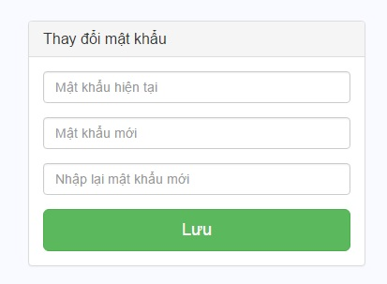

Figure ‑: Change password screen

|  |  |  |  |  |  |  |  |
| --- | --- | --- | --- | --- | --- | --- | --- |
| No | Field name | Field name in Vietnamese | Type | Require | Mandatory | Max-Length | Description |
| 1. | Change password | Thay đổi mật khẩu | Label |  | Y |  | Display text |
| 2. | Current password | Mật khẩu hiện tại | password |  | Y |  | Current password of user |
| 3. | Password new | Mật khẩu mới | password |  | Y |  | Password new of user |
| 4. | Re-type password new | Nhập lại mật khẩu mới | password |  | Y |  | Re-type password new |
| 5. | Save | Lưu | Button | Click | Y |  | Click to save password new |

Table ‑: Change password screen

### Message content

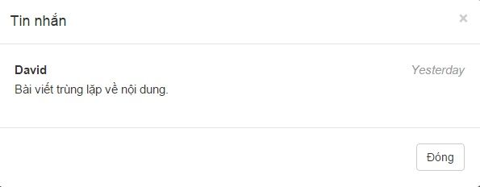

Figure ‑: Message content screen

|  |  |  |  |  |  |  |  |
| --- | --- | --- | --- | --- | --- | --- | --- |
| No | Field name | Field name in Vietnamese | Type | Require | Mandatory | Max-Length | Description |
| 1. | Message | Tin nhắn | Label |  | Y |  | Display text |
| 2. | Name | Tên | Text |  | Y |  | Name of sender |
| 3. | Content | Nội dung | Textarea |  | Y |  | Message content |
| 4. | Date | Thời gian | Date |  | Y |  | Received date of message |
| 5. | Close | Đóng | Button | Click | Y |  | Click to close massage content |

Table ‑: Message content screen

## Admin

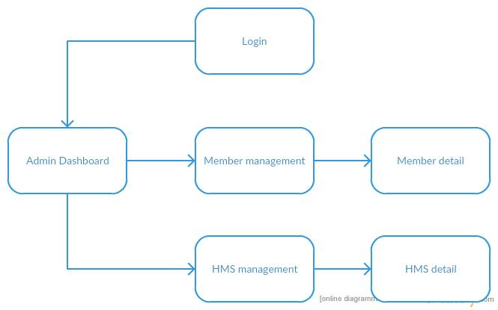

Figure ‑: Admin screen flow

### Dashboard of Admin

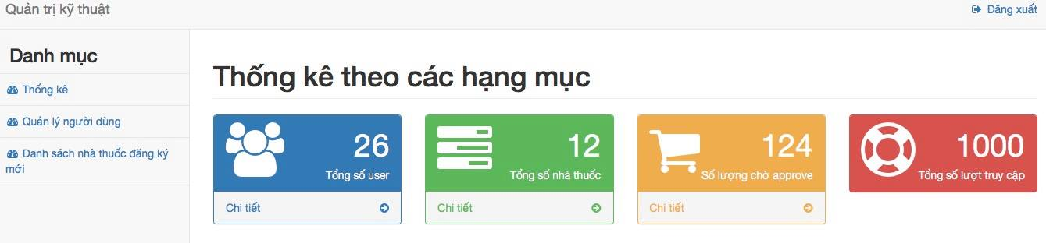

Figure ‑: Dashboard of Admin screen

|  |  |  |  |  |  |  |  |
| --- | --- | --- | --- | --- | --- | --- | --- |
| No | Field name | Field name in Vietnamese | Type | Require | Mandatory | Max-Length | Description |
| 1. | Technical manage | Quản trị kỹ thuật | Label |  | Y |  | Display title |
| 2. | Menu | Danh mục | Label |  | Y |  | Display text |
| 3. | Logout | Đăng xuất | Button | Click | Y |  | Click to logout |
| 4. | Dashboard | Thống kê | Button | Click | Y |  | Click to display dashboard of category |
| 5. | Managing user | Quản lý người dùng | Button | Click | Y |  | Click to display managing user |
| 6. | Herbal medicine store new list | Danh sách nhà thuốc đăng ký mới | Button | Click | Y |  | Click to display Herbal medicine store new list |
| 7. | Total of user | Tổng số user | Label |  | Y |  | Display label |
| 8. | Total of remedy | Tổng số nhà thuốc | Label |  | Y |  | Display label |
| 9. | Total of pending User | Số người chờ xử lý | Label |  | Y |  | Display label |
| 10. | Total of access times | Lượt truy cập | Label |  | Y |  | Display label |
| 11. | Detail | Chi tiết | Button | Click | Y |  | Click to view total of user, herbal medicine store, |

Table ‑: Dashboard of Admin screen

### Member management

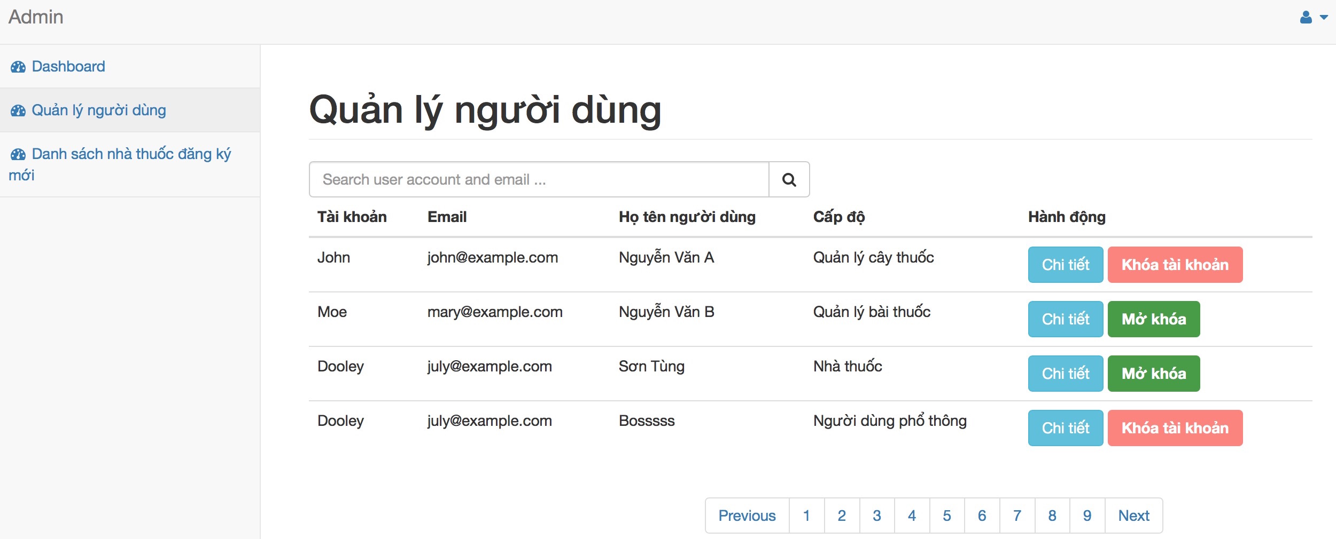

Figure ‑: Member management screen

|  |  |  |  |  |  |  |  |
| --- | --- | --- | --- | --- | --- | --- | --- |
| No | Field name | Field name in Vietnamese | Type | Require | Mandatory | Max-Length | Description |
| 1. | Member management | Quản lý người dùng | Label |  | Y |  | Display text |
| 2. | Search Box | Ô tìm kiếm | Text | Type | Y |  | Type user account or email to search |
| 3. | Search icon | Biểu tượng tìm kiếm | Button | Click | Y |  | Click to search user account |
| 4. | Account | Tài khoản | Text |  | Y |  | Show user account |
| 5. | Email | Địa chỉ hòm thư | Text |  | Y |  | Show user email |
| 6. | User’s full name | Họ và tên người dùng | Text |  | Y |  | Show user’s full name |
| 7. | Level | Cấp độ | Text |  | Y |  | Show user’s level |
| 8. | Action | Hành động | Text |  | Y |  | Show action: detail, lock, unlock account |
| 9. | Detail | Chi tiết | Button | Click | Y |  | Show detail |
| 10. | Lock account | Khoá tài khoản | Button | Click | Y |  | Lock user account |
| 11. | Unlock account | Mở khoá tài khoản | Button | Click | Y |  | Unlock user account |
| 12. | Pagging | Danh sách trang | Button | Click | Y |  | Moving between pages |

Table ‑: Member management screen

### Member detail

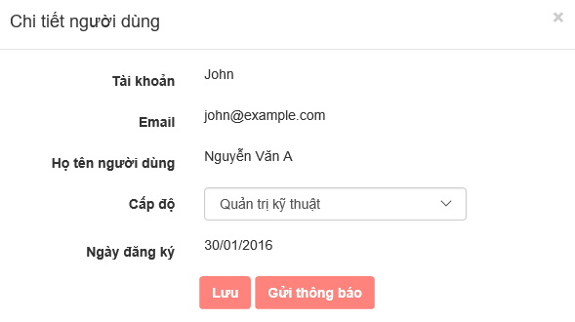

Figure ‑: Member detail screen

|  |  |  |  |  |  |  |  |
| --- | --- | --- | --- | --- | --- | --- | --- |
| No | Field name | Field name in Vietnamese | Type | Require | Mandatory | Max-Length | Description |
| 1. | Member detail | Chi tiết người dùng | Label |  | Y |  | Display text |
| 2. | Account | Tài khoản | Text |  | Y |  | Show user account |
| 3. | Email | Địa chỉ hòm thư | Email |  | Y |  | Show user’s email |
| 4. | Full name | Họ và tên người dùng | Text |  | Y |  | Show user’s full name |
| 5. | Level | Cấp độ | Dropdown list | Click | Y |  | Show user’s level |
| 6. | Register date | Ngày đăng ký | Date |  | Y |  | Show register date |
| 7. | Save | Lưu | Button | Click | Y |  | Click to save |
| 8. | Send message | Gửi thông báo | Button | Click | Y |  | Click to send message to this account |
| 9. | Close | Đóng | Button | Click | Y |  | Click to close this modal |

Table ‑: Member detail screen

### Herbal medicine store management

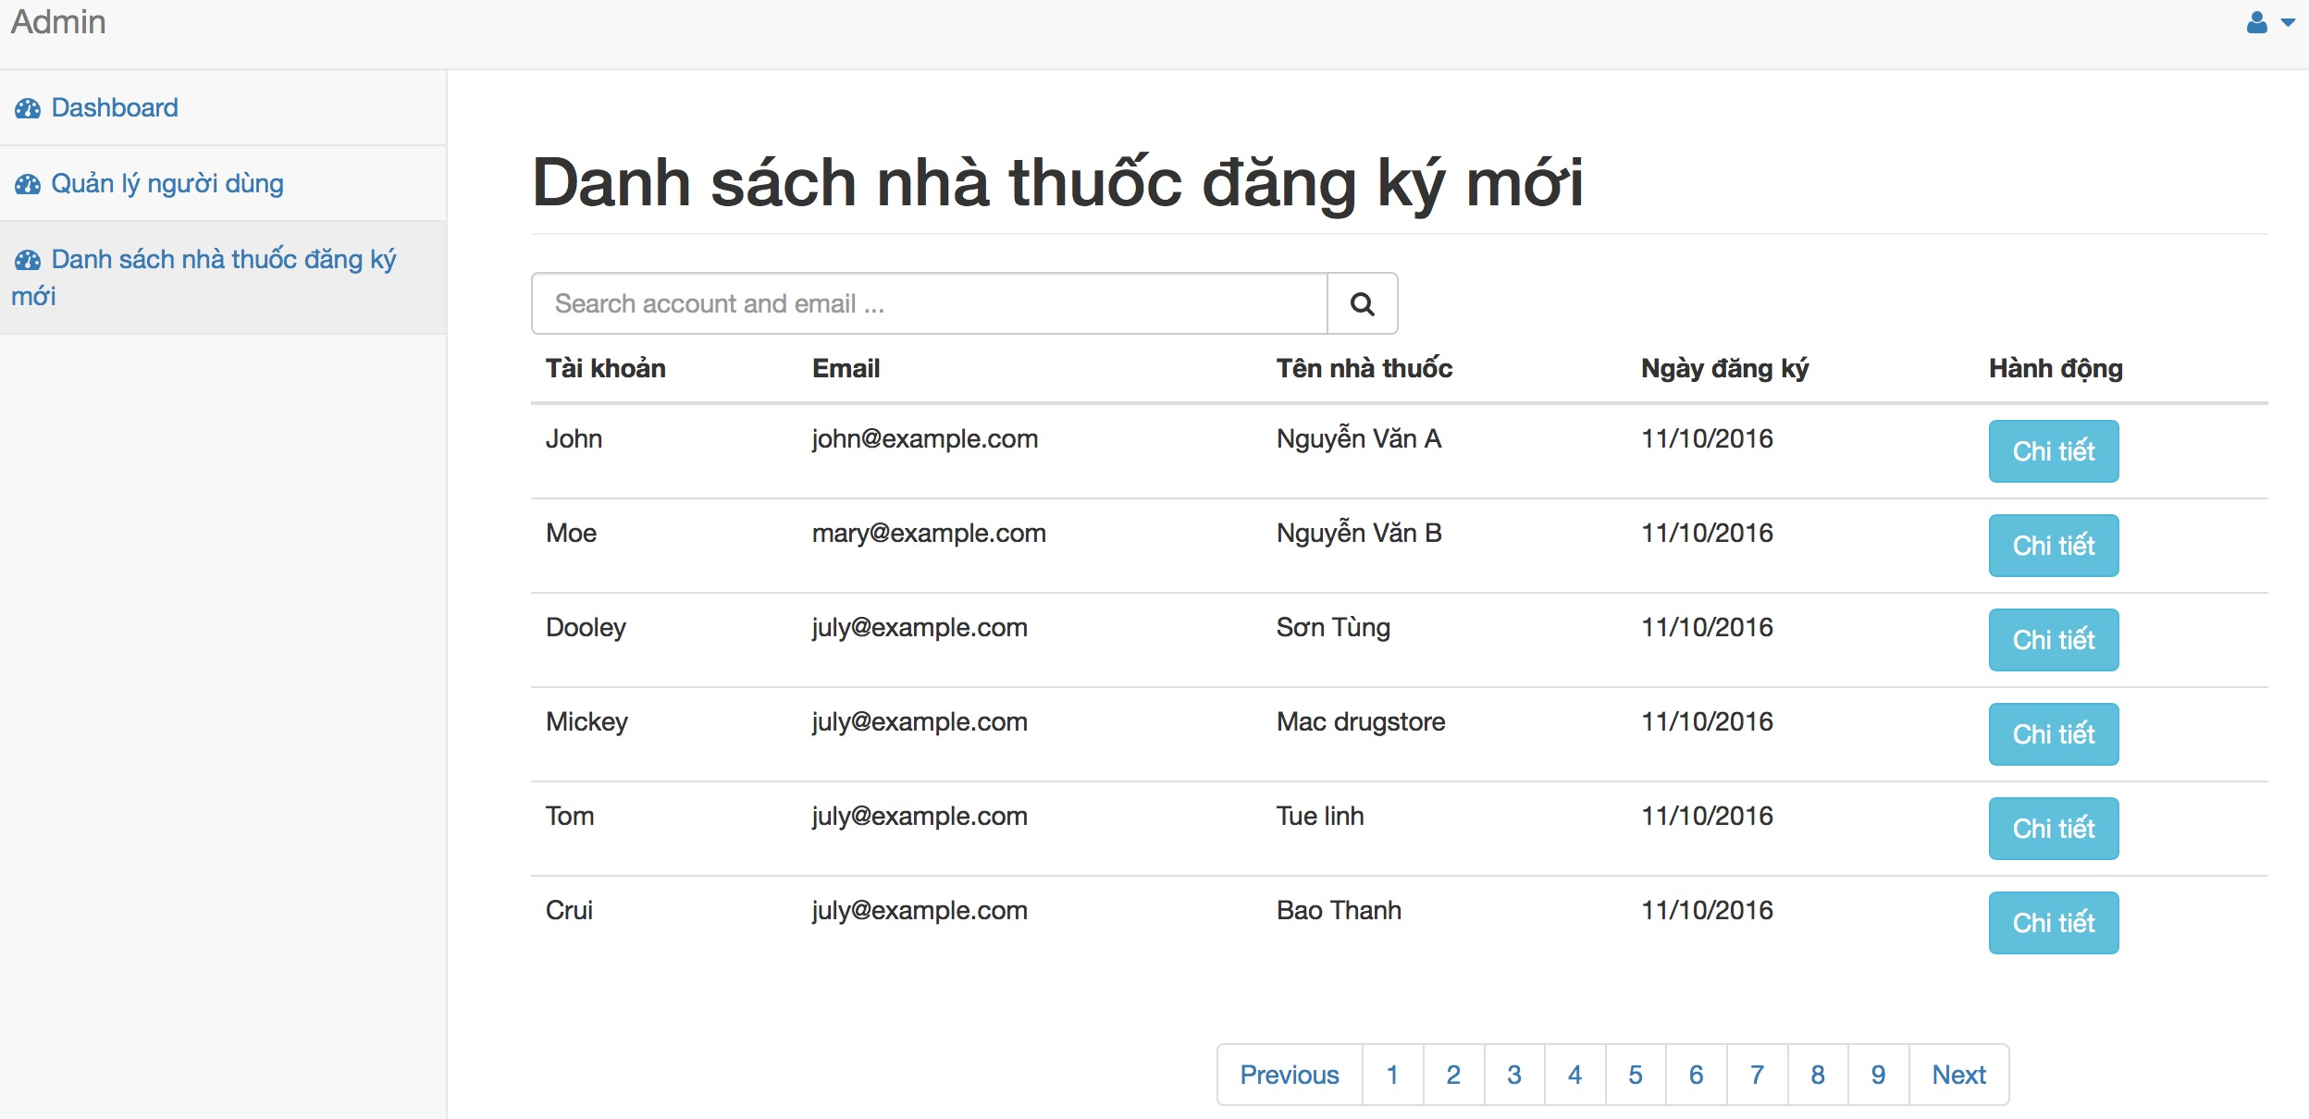

Figure ‑: Herbal medicine store management screen

|  |  |  |  |  |  |  |  |
| --- | --- | --- | --- | --- | --- | --- | --- |
| No | Field name | Field name in Vietnamese | Type | Require | Mandatory | Max-Length | Description |
| 1. | Herbal medicine store new list | Danh sách nhà thuốc đăng ký mới | Label |  | Y |  | Display text |
| 2. | Search Box | Ô tìm kiếm | Text | Type | Y |  | Type user account or email to search |
| 3. | Search icon | Biểu tượng tìm kiếm | Button | Click | Y |  | Click to search user account |
| 4. | Account | Tài khoản | Text |  | Y |  | Show user account |
| 5. | Email | Địa chỉ hòm thư | Text |  | Y |  | Show user email |
| 6. | Herbal medicine store | Tên nhà thuốc | Text |  | Y |  | Show herbal medicine store name |
| 7. | Register date | Ngày đăng ký | Date |  | Y |  | Show register date of store |
| 8. | Action | Hành động | Text |  | Y |  | Show action |
| 9. | Detail | Chi tiết | Button | Click | Y |  | Click to show detail |
| 10. | Pagging | Danh sách trang | Button | Click | Y |  | Moving pages |

Table ‑: Herbal medicine store management screen

### Herbal medicine store detail

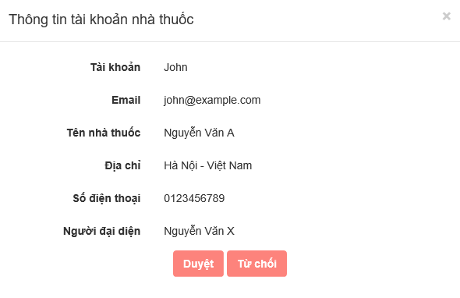

Figure ‑: Herbal medicine store detail screen

|  |  |  |  |  |  |  |  |
| --- | --- | --- | --- | --- | --- | --- | --- |
| No | Field name | Field name in Vietnamese | Type | Require | Mandatory | Max-Length | Description |
|  | Herbal medicine store account information | Thông tin tài khoản nhà thuốc | Label |  | Y |  | Display text |
|  | Account | Tài khoản | Text |  | Y |  | Show herbal medicine store account |
|  | Email | Địa chỉ hòm thư | Text |  | Y |  | Show herbal medicine store email |
|  | Herbal medicine store name | Tên nhà thuốc | Text |  | Y |  | Show herbal medicine store name |
|  | Address | Địa chỉ | Text |  | Y |  | Show herbal medicine store address |
|  | Phone | Số điện thoại | Text |  | Y |  | Show herbal medicine store phone |
|  | Representative | Người đại diện | Text |  | Y |  | Show representative name |
|  | Approve | Duyệt | Button | Click | Y |  | Click to approve account |
|  | Ignore | Từ chối | Button | Click | Y |  | Click to ignore account |

Table ‑: Herbal medicine store detail screen

## Mod

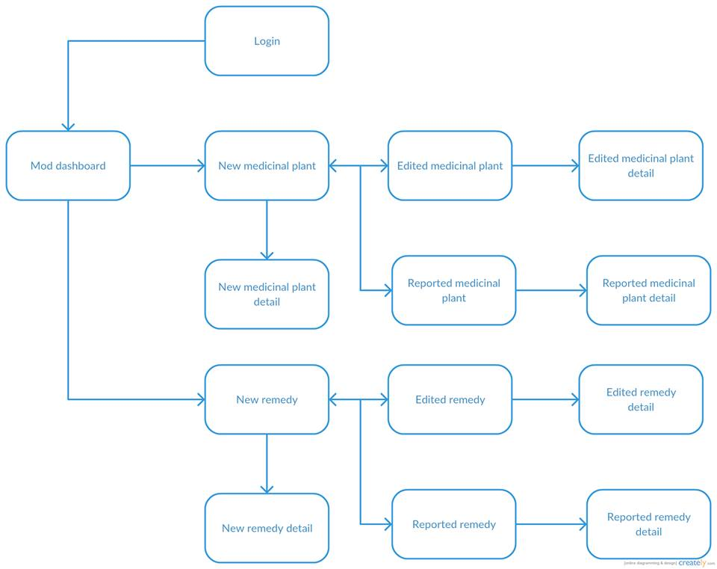

### Dashboard of Mod

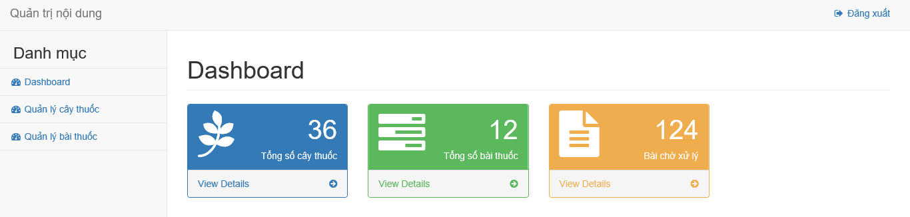

Figure ‑: Dashboard of Mod screen

|  |  |  |  |  |  |  |  |
| --- | --- | --- | --- | --- | --- | --- | --- |
| No | Field name | Field name in Vietnamese | Type | Require | Mandatory | Max-Length | Description |
| 1. | Content manage | Quản trị nội dung | Label |  | Y |  | Display title |
| 2. | Logout | Đăng xuất | Button | Click | Y |  | Click to logout |
| 3. | Dashboard | Bảng điều khiển | Button | Click | Y |  | Display dashboard of category |
| 4. | Manage medicinal plant | Quản lý cây thuốc | Button | Click | Y |  | Display managing medicinal plant of category |
| 5. | Manage medicine | Quản lý bài thuốc | Button | Click | Y |  | Display managing medicine of category |
| 6. | Total of medicinal plant | Tổng số cây thuốc | Label |  | Y |  | Display label |
| 7. | Total of remedy | Tổng số bài thuốc | Label |  | Y |  | Display label |
| 8. | Pending articles | Bài chờ xử lý | Label |  | Y |  | Display label |
| 9. | Detail | Chi tiết | Button |  | Y |  | Click to view total of medicinal plant or remedy or waiting or pending article |

Table ‑: Dashboard of Mod screen

### New medicinal plants management

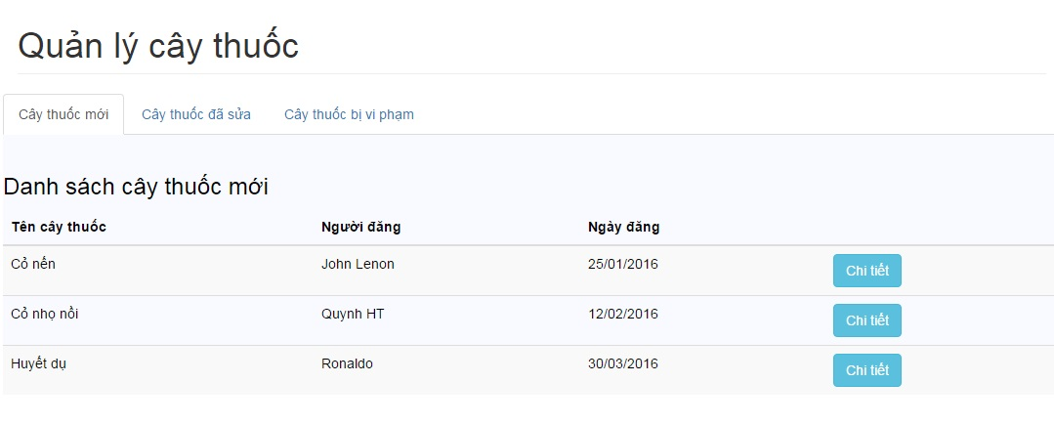

Figure ‑: New medicinal plant management screen

|  |  |  |  |  |  |  |  |
| --- | --- | --- | --- | --- | --- | --- | --- |
| No | Field name | Field name in Vietnamese | Type | Require | Mandatory | Max-Length | Description |
| 1. | Manage medicinal plant | Quản lý cây thuốc | Label |  | Y |  | Display title |
| 2. | New medicinal plants | Cây thuốc mới | Tab | Click | Y |  | Display tab |
| 3. | Edited medicinal plants | Cây thuốc đã sửa | Tab | Click | Y |  | Display tab |
| 4. | Reported medicinal plants | Cây thuốc vi phạm | Tab | Click | Y |  | Display tab |
| 5. | New medicinal plant article list | Danh sách cây thuốc mới | Label |  | Y |  | Display title of table |
| 6. | Medicinal plant | Tên cây thuốc | Text |  | Y |  | Display medicinal plant name |
| 7. | Author | Người đăng | Text |  | Y |  | Display author of this article |
| 8. | Posted date | Ngày đăng | Date |  | Y |  | Display posted date |
| 9. | Detail | Chi tiết | Button | Click | Y |  | Click to show detail |
| 10. | Dashboard | Bảng điều khiển | Button | Click | Y |  | Display dashboard of category |
| 11. | Manage medicine | Quản lý bài thuốc | Button | Click | Y |  | Display managing medicine of category |
| 12. | Logout | Đăng xuất | Button | Click | Y |  | Click to logout |

Table ‑: New medicinal plant management screen

### New medicinal plant detail

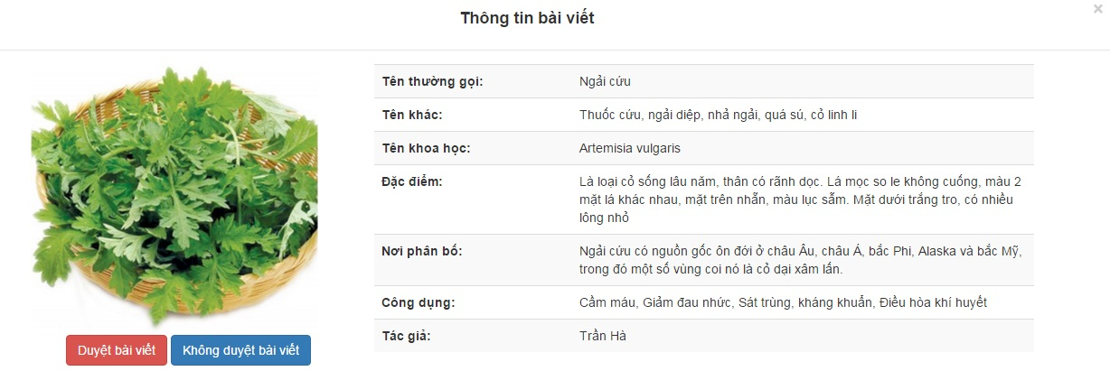

Figure ‑: New medicinal plants detail screen

|  |  |  |  |  |  |  |  |
| --- | --- | --- | --- | --- | --- | --- | --- |
| No | Field name | Field name in Vietnamese | Type | Require | Mandatory | Max-Length | Description |
| 1. | Medicinal plants Information | Thông tin cây thuốc | Label |  | Y |  | Display text |
| 2. | backgroud | Ảnh đại diện | Button | Click | Y |  | Click to show image of medicinal plants |
| 3. | Name | Tên | Text |  | Y |  | Name of medicinal plants |
| 4. | Other name | Tên khác | Text |  | Y |  | Other name of medicinal plants |
| 5. | Science name | Tên khoa học | Text |  | Y |  | Science name of medicinal plants |
| 6. | Characteristic | Đặc tính | Text |  | Y |  | Characteristic of medicinal plants |
| 7. | Utility | Công dụng | Text |  | Y |  | Utility of medicinal plants |
| 8. | Example picture | Ảnh minh họa | Button | Click | Y |  | Click to show example picture of medicinal plants |
| 9. | Note | Lưu ý | Text |  | Y |  | Note for medicinal plants |
| 10. | Allocation place | Nguồn gốc xuất xứ | Text |  | Y |  | Allocation place of medicine plant |
| 11. | Climatic condition | Điều kiện khí hậu nơi trồng | Text |  | Y |  | Climatic condition of medicinal plants |
| 12. | Author | Tác giả | Text |  | Y |  | Author of new medicinal plants |
| 13. | Approve | Duyệt | Button | Click | Y |  | Click to approve medicinal plants |
| 14. | Ignore | Từ chối | Button | Click | Y |  | Click to ignore medicinal plants |

Table ‑: New medicinal plants detail screen

### Edited medicinal plants management

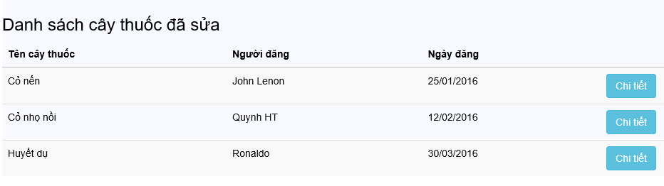

Figure ‑: Edited medicinal plants management

|  |  |  |  |  |  |  |  |
| --- | --- | --- | --- | --- | --- | --- | --- |
| No | Field name | Field name in Vietnamese | Type | Require | Mandatory | Max-Length | Description |
| 1. | Edited medicinal plant article list | Danh sách cây thuốc đã sửa | Label |  | Y |  | Display title of table |
| 2. | Medicinal plant | Tên cây thuốc | Text |  | Y |  | Display medicinal plant name |
| 3. | Author | Người đăng | Text |  | Y |  | Display author of this article |
| 4. | Posted date | Ngày đăng | Date |  | Y |  | Display posted date |
| 5. | Detail | Chi tiết | Button | Click | Y |  | Click to show detail |

Table ‑: Edited medicinal plants management screen

### Edited medicinal plant detail



Figure ‑: Edit medicinal plants detail screen

|  |  |  |  |  |  |  |  |
| --- | --- | --- | --- | --- | --- | --- | --- |
| No | Field name | Field name in Vietnamese | Type | Require | Mandatory | Max-Length | Description |
| 1. | Medicinal plants Information | Thông tin cây thuốc | Label |  | Y |  | Display text |
| 2. | backgroud | Ảnh đại diện | Button | Click | Y |  | Click to show image of medicinal plants |
| 3. | Name | Tên | Text |  | Y |  | Name of medicinal plants |
| 4. | Other name | Tên khác | Text |  | Y |  | Other name of medicinal plants |
| 5. | Science name | Tên khoa học | Text |  | Y |  | Science name of medicinal plants |
| 6. | Characteristic | Đặc tính | Text |  | Y |  | Characteristic of medicinal plants |
| 7. | Utility | Công dụng | Text |  | Y |  | Utility of medicinal plants |
| 8. | Example picture | Ảnh minh họa | Button | Click | Y |  | Click to up example picture of medicinal plants |
| 9. | Note | Lưu ý | Text |  | Y |  | Note for medicinal plants |
| 10. | Allocation place | Nguồn gốc xuất xứ | Text |  | Y |  | Allocation place of medicine plant |
| 11. | Climatic condition | Điều kiện khí hậu nơi trồng | Text |  | Y |  | Climatic condition of medicinal plants |
| 12. | Author | Tác giả | Text |  | Y |  | Author of new medicinal plants |
| 13. | Approve | Duyệt | Button | Click | Y |  | Click to approve medicinal plants |
| 14. | Ignore | Từ chối | Button | Click | Y |  | Click to ignore medicinal plants |

Table ‑: Edit medicinal plants detail screen

### Reported medicinal plants management

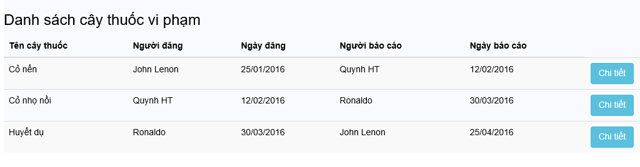

Figure ‑: Reported medicinal plants management screen

|  |  |  |  |  |  |  |  |
| --- | --- | --- | --- | --- | --- | --- | --- |
| No | Field name | Field name in Vietnamese | Type | Require | Mandatory | Max-Length | Description |
| 1. | Reported medicinal plant article list | Danh sách cây thuốc đã sửa | Label |  | Y |  | Display title of table |
| 2. | Medicinal plant | Tên cây thuốc | Text |  | Y |  | Display medicinal plant name |
| 3. | Author | Người đăng | Text |  | Y |  | Display author of this article |
| 4. | Posted date | Ngày đăng | Date |  | Y |  | Display posted date |
| 5. | Reporter | Người báo cáo | Text |  | Y |  | Display name of person who report |
| 6. | Reported date | Ngày báo cáo | Date |  | Y |  | Display reported date |
| 7. | Detail | Chi tiết | Button | Click | Y |  | Click to show detail |

Table ‑: Reported medicinal plants management screen

### Reported medicinal plant detail

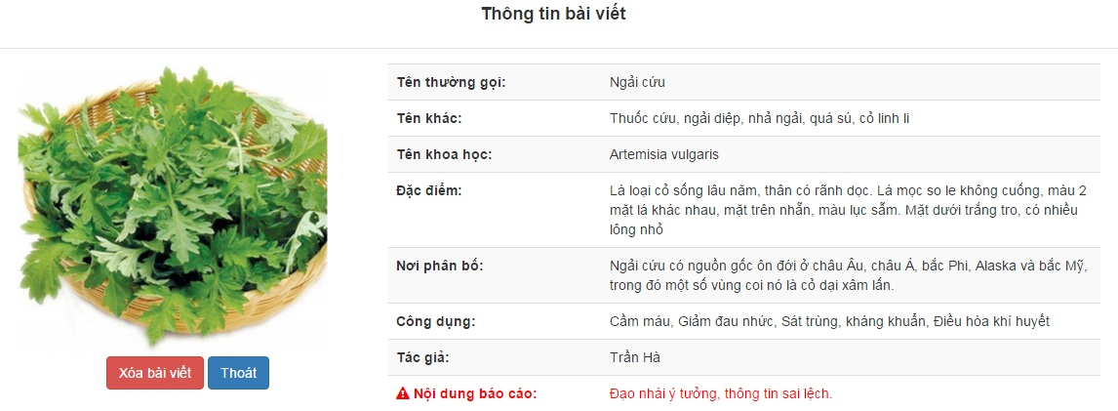

Figure ‑: Reported medicinal plants detail screen

|  |  |  |  |  |  |  |  |
| --- | --- | --- | --- | --- | --- | --- | --- |
| No | Field name | Field name in Vietnamese | Type | Require | Mandatory | Max-Length | Description |
| 1. | Medicinal plants Information | Thông tin cây thuốc | Label |  | Y |  | Display text |
| 2. | backgroud | Ảnh đại diện | Button | Click | Y |  | Click to show image of medicinal plants |
| 3. | Name | Tên | Text |  | Y |  | Name of medicinal plants |
| 4. | Other name | Tên khác | Text |  | Y |  | Other name of medicinal plants |
| 5. | Science name | Tên khoa học | Text |  | Y |  | Science name of medicinal plants |
| 6. | Characteristic | Đặc tính | Text |  | Y |  | Characteristic of medicinal plants |
| 7. | Utility | Công dụng | Text |  | Y |  | Utility of medicinal plants |
| 8. | Example picture | Ảnh minh họa | Button | Click | Y |  | Click to up example picture of medicinal plants |
| 9. | Note | Lưu ý | Text |  | Y |  | Note for medicinal plants |
| 10. | Allocation place | Nguồn gốc xuất xứ | Text |  | Y |  | Allocation place of medicine plant |
| 11. | Climatic condition | Điều kiện khí hậu nơi trồng | Text |  | Y |  | Climatic condition of medicinal plants |
| 12. | Author | Tác giả | Text |  | Y |  | Author of new medicinal plants |
| 13. | Reported content | Nội dung báo cáo | Text |  | Y |  | Content of Report |
| 14. | Delete | Xóa | Button | Click | Y |  | Click to delete reported medicinal plants |
| 15. | Ignore | Từ chối | Button | Click | Y |  | Click to ignore report |

Table ‑: Reported medicinal plants detail screen

### New remedy management

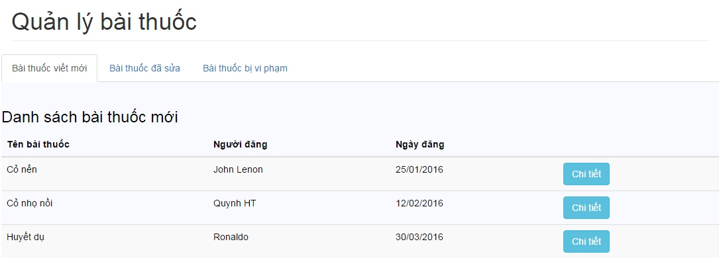

Figure ‑: New remedy management screen

|  |  |  |  |  |  |  |  |
| --- | --- | --- | --- | --- | --- | --- | --- |
| No | Field name | Field name in Vietnamese | Type | Require | Mandatory | Max-Length | Description |
| 1. | Manage remedy | Quản lý bài thuốc | Label |  | Y |  | Display title |
| 2. | New article | Bài viết mới | Tab | Click | Y |  | Display tab |
| 3. | Edited article | Bài viết đã sửa | Tab | Click | Y |  | Display tab |
| 4. | Reported article | Bài viết bị vi phạm | Tab | Click | Y |  | Display tab |
| 5. | New remedy list | Danh sách bài thuốc mới | Label |  | Y |  | Display title of table |
| 6. | Medicinal plant | Tên bài thuốc | Text |  | Y |  | Display remedy name |
| 7. | Author | Người đăng | Text |  | Y |  | Display author of this article |
| 8. | Posted date | Ngày đăng | Date |  | Y |  | Display posted date |
| 9. | Detail | Chi tiết | Button | Click | Y |  | Click to show detail |

Table ‑: New remedy management screen

### New remedy detail

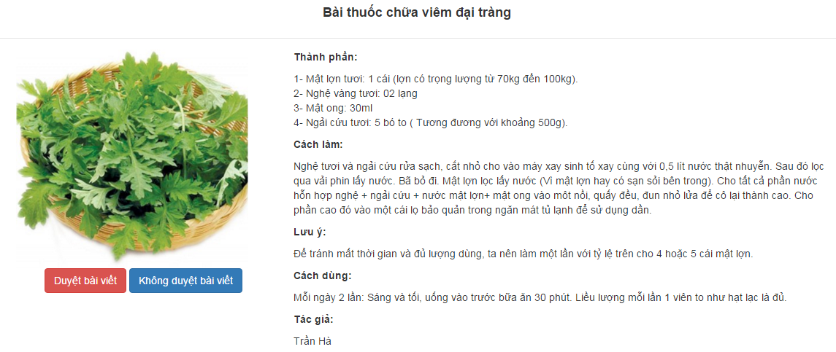

Figure ‑: New remedy detail screen

|  |  |  |  |  |  |  |  |
| --- | --- | --- | --- | --- | --- | --- | --- |
| No | Field name | Field name in Vietnamese | Type | Require | Mandatory | Max-Length | Description |
| 1. | New remedy information | Thông tin bài thuốc | Label |  | Y |  | Display text |
| 2. | Background | Ảnh đại diện | Button | Click | Y |  | Click to show image of remedy |
| 3. | Name | Tên | Text |  | Y |  | Name of remedy |
| 4. | Ingredients | Thành phần bài thuốc | Text |  | Y |  | Ingredients of remedy |
| 5. | Utility | Công dụng | Text |  | Y |  | Utility of remedy |
| 6. | Using | Cách sử dụng | Text |  | Y |  | Using of remedy |
| 7. | Making | Cách chế biến | Text |  | Y |  | Making of remedy |
| 8. | Example pictures | Ảnh minh họa | Text |  | Y |  | Click to show example pictures |
| 9. | Note | Lưu ý | Text |  | Y |  | Note for remedy |
| 10. | The origin | Nguồn gốc xuất xứ | Text |  | Y |  | The origin of remedy |
| 11. | Author | Tác giả | Text |  | Y |  | Author of remedy |
| 12. | Approve | Duyệt | Button | Click | Y |  | Click to approve new remedy |
| 13. | Ignore | Từ chối | Button | Click | Y |  | Click to ignore new remedy |

Table ‑: New remedy detail screen

### Edited remedy management

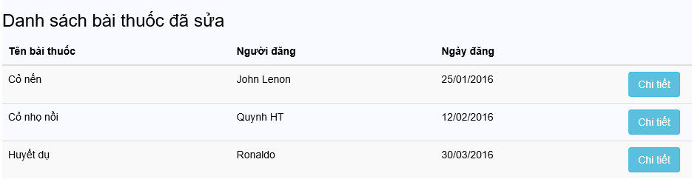

Figure ‑: Edited remedy management screen

|  |  |  |  |  |  |  |  |
| --- | --- | --- | --- | --- | --- | --- | --- |
| No | Field name | Field name in Vietnamese | Type | Require | Mandatory | Max-Length | Description |
| 1. | Edited remedy article list | Danh sách bài thuốc đã sửa | Label |  | Y |  | Display title of table |
| 2. | Remedy | Tên bài thuốc | Text |  | Y |  | Display remedy name |
| 3. | Author | Người đăng | Text |  | Y |  | Display author of this article |
| 4. | Posted date | Ngày đăng | Date |  | Y |  | Display posted date |
| 5. | Detail | Chi tiết | Button | Click | Y |  | Click to show detail |

Table ‑: Edited remedy management screen

### Edited remedy detail



Figure ‑: Edited remedy detail screen

|  |  |  |  |  |  |  |  |
| --- | --- | --- | --- | --- | --- | --- | --- |
| No | Field name | Field name in Vietnamese | Type | Require | Mandatory | Max-Length | Description |
| 1. | New remedy information | Thông tin bài thuốc | Label |  | Y |  | Display text |
| 2. | Background | Ảnh đại diện | Button | Click | Y |  | Click to show image of remedy |
| 3. | Name | Tên | Text |  | Y |  | Name of remedy |
| 4. | Ingredients | Thành phần bài thuốc | Text |  | Y |  | Ingredients of remedy |
| 5. | Utility | Công dụng | Text |  | Y |  | Utility of remedy |
| 6. | Using | Cách sử dụng | Text |  | Y |  | Using of remedy |
| 7. | Making | Cách chế biến | Text |  | Y |  | Making of remedy |
| 8. | Example pictures | Ảnh minh họa | Text |  | Y |  | Click to show example pictures |
| 9. | Note | Lưu ý | Text |  | Y |  | Note for remedy |
| 10. | The origin | Nguồn gốc xuất xứ | Text |  | Y |  | The origin of remedy |
| 11. | Author | Tác giả | Text |  | Y |  | Author of remedy |
| 12. | Approve | Duyệt | Button | Click | Y |  | Click to approve new remedy |
| 13. | Ignore | Từ chối | Button | Click | Y |  | Click to ignore new remedy |

Table ‑: Edited remedy detail screen

### Reported remedy management



Figure ‑: Reported remedy management screen

|  |  |  |  |  |  |  |  |
| --- | --- | --- | --- | --- | --- | --- | --- |
| No | Field name | Field name in Vietnamese | Type | Require | Mandatory | Max-Length | Description |
| 1. | Reported remedy article list | Danh sách bài thuốc đã sửa | Label |  | Y |  | Display title of table |
| 2. | Remedy | Tên cây thuốc | Text |  | Y |  | Display remedy name |
| 3. | Author | Người đăng | Text |  | Y |  | Display author of this article |
| 4. | Posted date | Ngày đăng | Date |  | Y |  | Display posted date |
| 5. | Reporter | Người báo cáo | Text |  | Y |  | Display name of person who report |
| 6. | Reported date | Ngày báo cáo | Date |  | Y |  | Display reported date |
| 7. | Detail | Chi tiết | Button | Click | Y |  | Click to show detail |

Table ‑: Reported remedy management screen

### Reported remedy detail

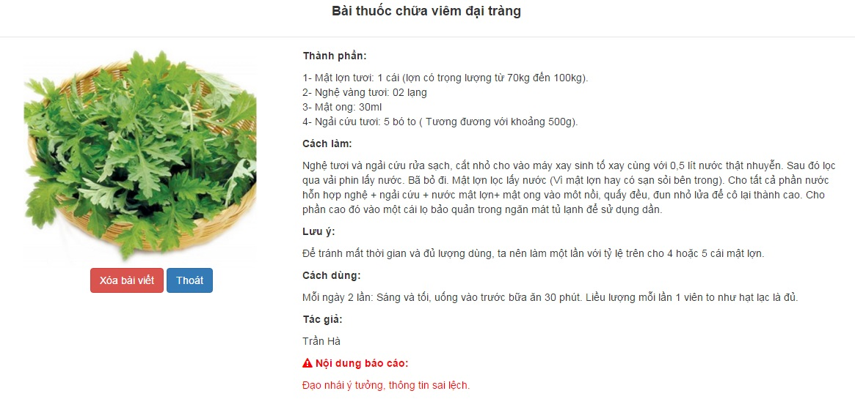

Figure ‑: Reported remedy detail screen

|  |  |  |  |  |  |  |  |
| --- | --- | --- | --- | --- | --- | --- | --- |
| No | Field name | Field name in Vietnamese | Type | Require | Mandatory | Max-Length | Description |
| 1. | New remedy information | Thông tin bài thuốc | Label |  | Y |  | Display text |
| 2. | Background | Ảnh đại diện | Button | Click | Y |  | Click to show image of remedy |
| 3. | Name | Tên | Text |  | Y |  | Name of remedy |
| 4. | Ingredients | Thành phần bài thuốc | Text |  | Y |  | Ingredients of remedy |
| 5. | Utility | Công dụng | Text |  | Y |  | Utility of remedy |
| 6. | Using | Cách sử dụng | Text |  | Y |  | Using of remedy |
| 7. | Making | Cách chế biến | Text |  | Y |  | Making of remedy |
| 8. | Example pictures | Ảnh minh họa | Text |  | Y |  | Click to show example pictures |
| 9. | Note | Lưu ý | Text |  | Y |  | Note for remedy |
| 10. | The origin | Nguồn gốc xuất xứ | Text |  | Y |  | The origin of remedy |
| 11. | Author | Tác giả | Text |  | Y |  | Author of remedy |
| 12. | Reported content | Nội dung báo cáo | Text |  | Y |  | Content of Report |
| 13. | Delete | Xóa | Button | Click | Y |  | Click to delete reported remedy |
| 14. | Ignore | Từ chối | Button | Click | Y |  | Click to ignore report |

Table ‑: Reported remedy detail screen